**SOP REVISED****TREATMENT REVISED**

**CHAPTER I**

**THE PROBLEM AND ITS SCOPE**

**Rationale of the Study**

The world currently faces an alarming crisis of plastic pollution, posing not only a messy problem but also a significant danger to ecosystems and human health. The ubiquity of cheap and convenient plastic bottles has led to their widespread use, but their disposal presents a monumental challenge. As discarded plastic accumulates in landfills and oceans, it wreaks havoc on wildlife, ecosystems, and even the air we breathe, exacerbating climate change. Globally, the scale of plastic pollution is staggering, with millions of metric tons entering our oceans annually, creating vast "plastic islands" and threatening marine life. This environmental crisis also poses health risks to humans, as micro plastics infiltrate water sources and the food chain.

In the Philippines, the problem of plastic pollution is particularly acute, with inadequate waste management infrastructure and high plastic consumption contributing to the country's status as one of the top contributors to plastic pollution worldwide. The Ocean Conservancy and the McKinsey Center for Business and Environment report that the Philippines alone generates nearly 1.88 million metric tons of mismanaged plastic waste annually, leading to waterway clogging, ecosystem degradation, and urban flooding.

At the local level, the situation reflects the national crisis, presenting both challenges and opportunities for intervention. Many communities, including educational institutions like Cebu Technological University- Argao Campus, struggle with inefficient waste management systems, resulting in the indiscriminate disposal of plastic bottles and other waste materials. However, educational institutions also represent a unique opportunity for change, with students playing a crucial role as stakeholders. Through their collective purchasing power and advocacy efforts, students can influence administrative decisions and promote environmentally sustainable practices on college campuses.

To address the issue of plastic bottle management effectively, it is crucial to implement regulations and initiatives that encourage reduced waste, increased recycling, and proper disposal. Individual actions, such as segregating recyclable materials, can significantly contribute to positive change. Additionally, leveraging technology, particularly the Internet of Things (IoT), offers innovative solutions to contemporary challenges. By integrating IoT devices and systems into plastic bottle management, a trading system can incentivize responsible disposal practices among students and staff. This cutting-edge approach utilizes rewards and advantages to motivate participants, while real-time monitoring and data collection ensure efficiency and accuracy.

The proposed IoT-based plastic bottle trading system, tailored for Cebu Technological University- Argao Campus, aims to revolutionize plastic waste management within academic environments. Through the seamless integration of IoT sensors, smart bins, and a user-friendly web application, the system will facilitate the collection, disposal, and incentivization of plastic bottle recycling. By fostering a culture of environmental responsibility and sustainability, this innovative initiative sets a precedent for similar efforts globally, demonstrating the transformative potential of technology in addressing pressing environmental challenges.

**Theoretical Background**

This section aims to elucidate the theories, concepts, and analytical models pertinent to the subject matter.

The **Theory of Planned Behavior** (TPB) serves as a valuable framework for comprehending plastic waste sorting intentions among students. Attitudes and subjective norms, integral components of the TPB, influence Perceived Behavioral Control (PBC), which evaluates the individual's ability to sort plastic waste amidst social pressures and expectations. Within this context, subjective norms reflect societal influences on students' sorting behavior, while PBC assesses the practical barriers and motivators affecting their participation. By exploring these elements, the TPB aids in identifying key determinants of plastic waste sorting intentions, guiding efforts to enhance environmental consciousness and sustainable practices among university students. This theoretical approach highlights the importance of addressing both individual attitudes and the broader social context in promoting sustainable waste management behaviors.

In connection to the study, TPB informs the development of the proposed IoT trading system for plastic bottle management. By understanding CTU- Argao students' attitudes, norms, and perceived control, the system can effectively motivate and facilitate proper plastic waste disposal. Features that reinforce positive recycling attitudes, align with campus norms, and reduce participation barriers can enhance perceived control and engagement. Integrating TPB insights into the IoT system design can lead to higher adoption rates and effective waste management, fostering a culture of sustainability within the university.

The **Hybrid Agile-Waterfall Development Model**, in terms of transition ease and cost effectiveness, this model is the most efficient approach. According to Zaleski (2024) in a hybrid model, waterfall provides the overall structure for the well-understood, predictive aspects of the project, and agile techniques are used for the iterative, more uncertain parts. The integration of Agile and Waterfall is seen as a practical strategy to maintain the integrity of essential project elements while adapting to the more agile requirements.

In the context of the study, this hybrid model proves beneficial in effectively addressing project challenges. By harnessing the structured nature of the waterfall model for defining and designing critical components, such as those in the IoT trading system, and integrating agile methodologies for development, testing, deployment, and maintenance phases, the approach facilitates smooth transition management, risk reduction, and cost-effectiveness throughout the project lifecycle. This combination ensures that the project remains flexible and adaptable while adhering to necessary procedural rigor.

The **Technology Acceptance Model (TAM)**, the acceptance of information systems by individuals is explained by this model. According to TAM, technology adoption is predicted by users' behavioral intention, which is defined as the individual’s intentions to use the technology increase, they are more likely to actually use the technology (Worthington, A. K., & Burgess, G. L., 2021).

In connection with the study, The Technology Acceptance Model (TAM) proves handy in examining and forecasting how people accept and use a system. It uncovers the intentions behind users' actions, shaped by how they see the system's usefulness and ease of use. If a system is created to be seen as helpful and user-friendly, considering feedback from users, and offering sufficient training and support, it increases the likelihood of users adopting and using the system effectively, especially in the context of managing plastic bottles. This model underscores the importance of user perceptions in the successful implementation and sustainability of technological solutions in waste management.

Theory of Planned Behavior

Technology Acceptance Model (TAM)

Hybrid Agile-Waterfall Development Model

**Current Status of Waste Segregation in CTU-Argao**

**Challenges Encountered in Plastic Waste Management**

*Fig. 1: A Schematic Diagram of the Theoretical Framework of the Study*

**Review of Related Literature and Studies**

**Related Literature**

This section presents a thorough understanding of the topic related to the current research study.

According to Katade et al. (2021), the renowned saying of Sir Francis Bacon, "Cleanliness is next to Godliness," underscores the imperative of maintaining orderly environments. It is the responsibility of individuals to ensure both public and private spaces remain tidy. However, as the global population continues to grow and societies strive for development, there has been a surge in waste generation. This has raised concerns about waste disposal methods, including the disposal of large quantities of garbage in ways that harm the natural environment, such as unregulated open dumping in landfill sites.

The rapid expansion of economic activities, urbanization, and industrialization has resulted in a significant increase in both conventional and toxic waste, highlighting the urgent need for effective and environmentally friendly waste management strategies. Automatic garbage segregation emerges as a viable solution to this challenge, facilitating recycling and becoming an essential component of modern waste management practices. Moreover, breaking down garbage into its constituent components not only helps to recognize its importance but also reveals its economic value (Rajesh et. al., 2023).

The rising volume of daily waste production drives up the costs associated with waste management and sanitation, necessitating the implementation of more efficient monitoring and management systems. Furthermore, according to studies by Nooriman et.al. (2021), there is a growing demand for the integration of Internet of Things (IoT) technology, especially within the context of the Fourth Industrial Revolution (IR4.0).

In today's world, numerous systems are being automated through IoT, reducing the need for extensive human involvement, and minimizing the potential for human error. However, the integration of IoT also generates vast amounts of real-time data, which must be properly interpreted and utilized to ensure effective waste management practices (Katade et.al, 2021).

Further supporting the integration of IoT in waste management, Bhattacharya et al. (2022) discuss the role of IoT-enabled smart bins in urban waste management. These smart bins are equipped with sensors that detect fill levels and communicate this data to waste management systems, optimizing collection routes and reducing operational costs. The deployment of such smart bins in cities has shown a marked improvement in waste collection efficiency and a reduction in littering.

Additionally, Kumar et al. (2022) highlight the potential of IoT in enhancing recycling efforts. Their research indicates that IoT devices can be used to monitor recycling bins and provide real-time data on recycling behaviors. This information can be used to educate the public about proper recycling practices and to identify areas where recycling rates are low, allowing for targeted interventions.

Singh and Kumar (2020) explore the economic benefits of IoT-based waste management systems. By optimizing waste collection routes and reducing the frequency of pickups, municipalities can significantly lower fuel consumption and labor costs. Moreover, real-time data analytics can help in predicting waste generation trends, aiding in better resource allocation and planning.

Moreover, the concept of the circular economy is gaining traction as a sustainable approach to waste management. Ellen MacArthur Foundation (2021) emphasizes the importance of designing products and systems that minimize waste and maximize the reuse, recycling, and recovery of materials. IoT technology can facilitate the circular economy by providing precise data on material flows and enabling better tracking of products throughout their lifecycle.

Finally, Ma et al. (2021) examine the environmental impact of plastic waste and the critical role of policy in mitigating this issue. They argue that combining technological innovations, such as IoT-based waste management systems, with robust regulatory frameworks can lead to significant reductions in plastic pollution. Policies that incentivize recycling and the use of eco-friendly materials, along with the deployment of smart waste management technologies, can create a comprehensive approach to addressing plastic waste.

**Related Studies**

This section delves into previous studies that are related to our current research that are helpful to understand and put the current study in context.

A smart waste management system has been developed by researchers at the Department of Electrical, Electronic, and Systems Engineering of Universiti Kebangsaan Malaysia. This system utilizes the LoRa communication protocol alongside a TensorFlow-based deep learning model. LoRa facilitates the transmission of sensor data, while TensorFlow conducts real-time object detection and classification. The waste bin comprises multiple compartments designed for segregating different types of waste, such as metal, plastic, paper, and general waste, with each compartment controlled by servo motors. The TensorFlow framework, utilizing a pre-trained object detection model, is employed for object detection and waste classification. The object detection model is trained using waste images to generate a frozen inference graph utilized for object detection. This detection process is executed through a camera connected to the Raspberry Pi 3 Model B+, which serves as the main processing unit. Additionally, ultrasonic sensors are incorporated into each waste compartment to monitor waste filling levels, while a GPS module tracks the bin's location and real-time status. Data regarding the bin's location, real-time status, and filling level are transmitted using the LoRa communication protocol. Furthermore, an RFID module is integrated for waste management personnel identification purposes (Sheng et al., 2020).

Moreover, in their study titled "IoT (Internet of Things)-Based Smart Garbage Management System,” Bhowmik, Miah, and Mohaimen-Bin-Noor (2020) have devised a sophisticated waste management solution comprising sensors, RFID technology, IR sensors, an administrative interface, a user website, and a Wi-Fi module, among other components. These intelligent receptacles are designed to monitor garbage levels, issuing notifications to the administrative website once the waste reaches 75% capacity. This timely notification enables the relevant authorities to promptly collect the garbage, thus mitigating the risk of overflow. The user website will include functionality to inform users about the current status of the nearest smart garbage bins. Consequently, if a user discovers that their local bin is full, they can easily locate and utilize the nearest available bin. Furthermore, this research endeavor prioritizes the security of these smart garbage bins, acknowledging the potential risks of theft and damage. To address these concerns, the research delves into safeguarding the sensors and proposes constructing the bins with a robust cement body. Thus, the overarching goal of this study is to implement an efficient garbage management system that not only reduces operational costs but also combats misuse of the bins.

The utilization of blockchain technology within waste management was additionally introduced in the research study titled "Implementation of Blockchain Technology in Waste Management." The primary objective of this study is to demonstrate the integration of blockchain technology within an established waste management enterprise, leveraging smart contracts within the recycling process to ensure transparency. Furthermore, the concept of the digital product passport was reimagined within the framework of circular economy principles and waste recycling. This passport could be manifested through a QR code or a specialized Radio Frequency Identification/Near Field Communication (RFID/NFC) chip. Employing a two-dimensional code, easily scannable with smartphones or dedicated readers, enables the storage of extensive information that can be effortlessly printed on diverse materials. Positioned on product packaging, the QR code, upon scanning, directs users to a blockchain ledger containing details regarding the waste's provenance. In relation to RFID/NFC, items can be remotely tracked via radio waves. This tracking process operates automatically, the solution is resistant to adverse weather conditions, and data can be directly stored on the chip and linked to the blockchain in the form of a non-fungible token (NFT). (Bułkowska, Zielińska, and Bułkowski, 2023).

Additionally, Fadel (2017) devised a system featuring a cost-effective design for an intelligent waste container tailored for small-scale applications. This system employs an Arduino Nano board in conjunction with an ultrasonic sensor to monitor the level of fullness within the container and dispatch SMS alerts via a GSM module accordingly. Powered by a lithium battery power bank supplemented by a solar cell panel, the system offers the capability to charge external portable devices through the power bank. Furthermore, the system records usage events via a PIR sensor and fullness events onto a memory card. This memory card is also utilized to play audio messages through a speaker when the bin is in use. The system is implemented successfully with an acceptable overall cost for the intended application. The system’s performance was found satisfactory according to the obtained test results.

With the rapid expansion of the population, numerous challenges emerge concerning waste disposal sites. These sites emit hazardous gases that pose detrimental effects on human health. A primary concern revolves around the collection, management, and categorization of domestic solid waste. Research indicates that in America, approximately 75% of waste can be recycled; however, due to the absence of an efficient real-time waste-segregating mechanism, only 30% of waste is currently recycled. To uphold a pristine and eco-friendly environment, the implementation of a smart waste management and classification system becomes imperative. In response to the aforementioned issue, a real-time smart waste management and classification mechanism, referred to as SWMACM-CA, has been proposed. This innovative approach integrates the Internet of Things (IoT), deep learning (DL), and state-of-the-art techniques to classify and segregate waste items within dump areas. (Cheema, Hannan, and Pires, 2022).

Furthermore, the system incorporates a waste grid segmentation mechanism designed to partition the waste yard pile into grid-like segments. An onboard camera captures the image of the waste yard, transmitting it to an edge node for the creation of a waste grid. These grid cell image segments serve as test images for a trained deep learning model, enabling specific waste item predictions. The deep learning algorithm utilized for this project is the Visual Geometry Group with 16 layers (VGG16). To reduce overall latency, the model is trained on a cloud server deployed at the edge node.

Aniqa et al. (2020) have developed a Smart Bin Mechanism (SBM) tailored for smart cities, leveraging Artificial Intelligence of Things (AIoT) to uphold urban cleanliness and facilitate real-time monitoring of trash bins. Operating on the principles of the 3R concept—Reduce, Recycle, and Reuse—the SBM enables access to real-time information for each bin, thereby preventing bin overload. The proposed framework not only diminishes labor costs but also conserves time and energy within the system. Furthermore, it plays a pivotal role in curbing the spread of diseases by maintaining city cleanliness. Fuzzy logic serves as the decision-making tool for selecting appropriate bin locations within the cities. The framework is implemented within the multi-agent modeling environment, NetLogo.

In the research study titled "Smart Dustbins: Automatic Segregation and Efficient Solid Waste Management Using IoT Solutions for Smart Cities,” an IoT-based smart dustbin monitoring system is proposed, integrating dynamic scheduling and routing for trash collectors alongside moisture detection capabilities for smart dustbins. The system transmits real-time status updates for each smart bin to the cloud, facilitating efficient monitoring. Additionally, a mobile application aids trash collectors by providing optimal dynamic routes. Municipal corporations oversee the entire waste collection process through this system. Furthermore, the study suggests a method for automatic segregation of wet and dry waste using moisture detection technology. The automatic segregation of wet and dry waste proves useful to identify economic value of waste and also manage the waste efficiently. (Chachra, 2020).

Pratap et al. (2019) have introduced a system in India that employs IoT technology to facilitate a smart and automated method for plastic collection. This system establishes a connection between households and waste collection teams from municipal corporations or designated organizations, enabling a semi-automated and efficient collection process. The envisioned outcome of this initiative is the development of a smart and automated residential plastic waste collection system centered on IoT principles. By incentivizing the use of smart bins, individuals are expected to receive E-tokens as rewards. The value of the plastic waste received by the organization serves as motivation for individuals to utilize the smart bins, ultimately leading to a plastic-free environment over time. The key advantage of this project lies in its inclusive approach, which welcomes the collection of various plastic-based products, given the escalating threat posed by plastic to humanity.

Table 1.

**Comparative Matrix for Related Projects**

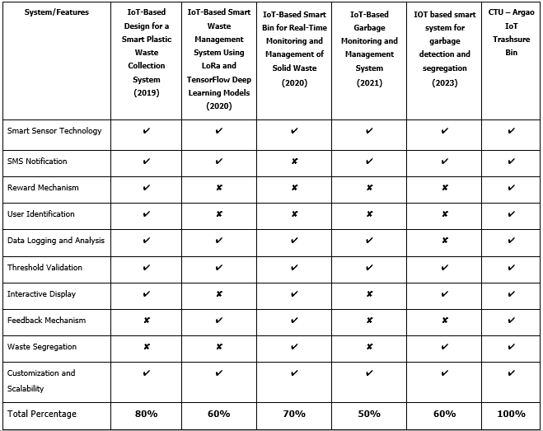

**Legend:** ✔ - **Applicable** **✘** - **Not Applicable**

**STATEMENT OF THE PROBLEM**

Plastic pollution continues to pose a significant environmental challenge globally and locally, including at Cebu Technological University - Argao Campus. To address this pressing issue, this study aims to analyze and design an innovative solution by developing and evaluating the efficacy of an innovative IoT Trash Bin Trading System. The primary objective is to reduce the presence of plastic bottles within the campus premises throughout the Academic Year of 2024-2025.

Specifically, it seeks to answer the following research questions:

1. What is the current status of waste segregation in CTU-Argao as to:
   1. Biodegradable; and
   2. Non-Biodegradable?

2. What are the challenges encountered by the respondents’ group in dealing with waste management?

3. What is the quality of the IoT-enabled Trashsure Bin System as rated by IT Experts using the ISO 9126 for Software Quality Standard?

3.1. Functionality;

3.2. Reliability;

3.3. Usability;

3.4. Efficiency;

3.5. Maintainability; and

3.6. Portability?

4. How will the IoT-enabled Trashsure Bin System be rated by the users and IT Experts in terms of:

4.1. Perceived ease-of-use; and

4.2. Perceived ease-of-usefulness?

5. Is there a significant difference between the users' rating and the IT experts' rating in terms of the perceived usefulness of the system?

**SCOPE AND LIMITATIONS OF THE STUDY**

This study focuses on the design, innovation, and operation of a plastic bottle exchange platform tailored for the students at Cebu Technological University – Argao Campus. It primarily addresses hard plastic waste, particularly plastic bottles, eligible for the IoT-enabled trash bin system. Collection points will be based only on the quantity of plastic bottles disposed of in the bin and the corresponding rewards, with each bottle accruing 5 points. Three reward options are currently offered: a pen (valued at 50 points), a pad of yellow paper (valued at 100 points), and load cards (valued at 150 points). Moreover, the rewards are dynamic, and the administrator can edit or change these depending on their availability of resources. The trash bin is equipped with a Bar Code reader for users to conveniently scan their school ID, with points automatically credited to their ID number. Additionally, a web-based monitoring system is incorporated, allowing users to monitor the status of the garbage trading bin, track the availability and updates of rewards, and receive notifications via SMS when trade-off products are depleted or when the garbage compartment reaches capacity. The trash bin includes sensors that detect full compartments and will further notify the administrator or maintenance personnel via SMS.

However, the study may encounter limitations including a finite sample size, potential biases in self-reported data, and limited generalizability beyond CTU -Argao Campus. Efforts will be made to mitigate these limitations by employing appropriate sample strategies, precise data collection and processing methods, and thorough interpretation of results within the study's context.

**SIGNIFICANCE OF THE STUDY**

This study will benefit the following entities:

**School Utilities / Janitors.** The adoption of the school's waste trading system can significantly alleviate the workload of janitorial staff. By implementing this system, janitors or cleaners will be able to concentrate on collecting and processing waste that has been pre-sorted by students.

**Teachers and Staff.** A clean and healthy environment is conducive to the overall well-being of teachers and staff, leading to heightened productivity and job satisfaction.

**Students.** As essential stakeholders in the school community, students will be encouraged and motivated to engage with the waste trading system responsibly. Their participation will serve as a model for others, promoting proper waste disposal practices.

**Cebu Technological University - Argao Campus.** The study aims to promote social responsibility and community engagement through the implementation of a plastic waste trading system. It seeks to cultivate eco-friendly behaviors and encourage a sense of ownership of waste among students. Additionally, it aims to foster a sense of community among students, teachers, and staff as they collaborate to reduce plastic waste within the campus environment.

**Future Researchers.** This study will serve as a valuable reference for future researchers involved in the development of related application software.

**RESEARCH METHODOLOGY**

This section outlines the research design, flow of the study, project environment or locale of the study, respondents, data instrument, and treatment of data to achieve the objectives for the project.

**Design**

The study will employ a descriptive type of research, involving the collection of relevant data related to the management of waste, particularly plastic bottles, within the campus of Cebu Technological University – Argao Campus. Researchers will analyze current challenges faced in waste management and focus on addressing the specific problem of plastic bottle waste. Additionally, a quantitative research method will be utilized to systematically gather and analyze data using quantitative methodologies. This will involve deploying IoT devices at designated waste collection points to collect data on plastic bottle collection and processing rates both before and after the implementation of the IOT Trashsure Bin.

The descriptive survey aims to assess the performance of the IOT Trashsure Bin according to software evaluation standards derived from ISO/IEC 9126-1 Software Engineering, focusing on internal and external quality, quality in use, as well as perceived ease-of-use and usefulness.

The design of the system will utilize an agile model, emphasizing iterative development and continuous improvement to enhance the efficiency and effectiveness of the software development process.

**Flow of the Study**

**Input.** The study focuses on addressing plastic pollution at Cebu Technological University-Argao Campus through the development and evaluation of an IoT Trash Bin Trading System for reducing plastic bottle waste during the Academic Year of 2024-2025. To achieve this, the research will gather data on current waste segregation practices, identify challenges in waste management, and define specifications for system development including hardware, software, database, and network requirements. Quality assessment will be conducted using the ISO 9126 Software Quality Standard, with feedback collected from users and IT experts to assess system usability and usefulness. A comparative analysis will then be performed to determine any significant differences in perceived usefulness ratings between users and IT experts. This approach ensures a comprehensive framework for effectively addressing plastic pollution on campus.

**Process**. The process shall begin by conducting an interview with the deans and officials of the department to discuss the issue and to gather data. It will be followed by the development phases such as requirements gathering, analyzing, designing, developing, and implementation of the system. In addition, to ascertain whether the proposed system is accepted, a test plan will be drawn up.

**Output**. The output of this study is enhancing the waste management in CTU-Argao through IOT-enabled Trashsure Bin System.

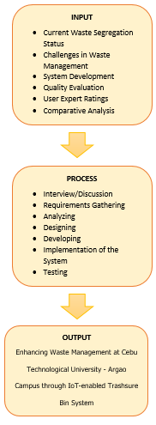

*Fig. 2: The Flow of the Study*

**Project Environment (Locale of the Study)**

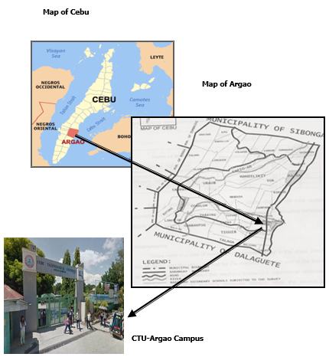The study will take place at Cebu Technological University - Argao Campus in Lamacan, Argao, Cebu. This locale provides an ideal environment for researching improved plastic bottle management using an innovative IoT trading system. Chosen for its supportive academic atmosphere and receptiveness to new ideas, the university offers opportunities for collaboration with the local community.

*Fig. 3: Location Map of the Research Environment*

**Respondents**

The respondents of the study will be the students, teachers and the faculty of Cebu Technological University- Argao Campus. For this study, a quota sampling technique will be employed for the student respondents where a uniform sample will be taken from the population. On the other hand, a universal sampling technique will be used in identifying the teacher respondents which can best provide the relevant information needed for the study. As shown in Table 2, respondents will be taken from different groups.

**Table 2.**

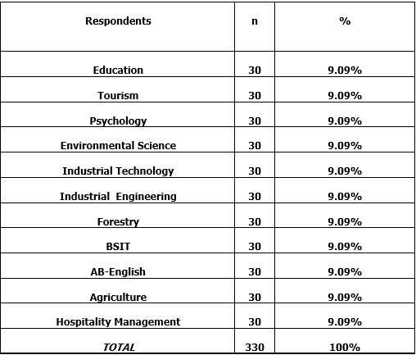**Respondents of the Study**

**Data Instrument**

For this study, the researchers will use survey questionnaires to gather relevant information to attain the objectives of the study. The respondents will be surveyed regarding the status or challenges of plastic waste management at CTU - Argao Campus, including the Likert Scale to rate the degree of seriousness of each status or challenge. To further answer the research questions, another survey for IT experts will measure how well each part of the system works, following the ISO/IEC 9126 standard. Moreover, the study will utilize the Likert scale based on the study, “Effects of Inappropriate Waste Management on Health: Knowledge, Attitude and Practice Among Malaysian Population” (Al-Naggar, et.al, 2019)

Table 3.

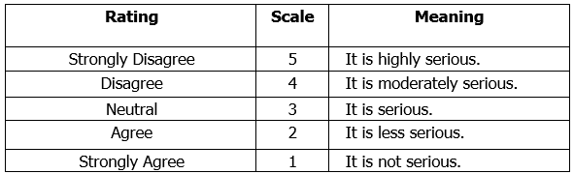**5-Point Likert Scale**

Table 4.

**Software Evaluation (Internal and External Quality) Criteria**

Table 5.

**Software Evaluation (Perceived Usefulness and Perceived Ease-of-Use) Criteria**

**Treatment of Data**

For the quantitative interpretation of data, the following statistical formulas will be used in the study.

1. **Weighted Mean** – This will be utilized in determining the status of the waste segregation at the CTU-Argao Campus.



, where:



= weighted mean



= frequency of each response

 = weight of each score

 = sum of all the products of and

= total number of cases

**SYSTEM METHODOLOGY**

**REQUIREMENTS SPECIFICATION**

The following are the requirements and specifications applicable to the IOT Trashsure Bin needs.

**Non-Functional Requirements**

**User-Friendliness**

This requirement focuses on the ease of use and understanding of the system by users, emphasizing clear instructions and intuitive design.

**Performance**

This requirement emphasizes the system's ability to perform efficiently, even with simultaneous use by the students.

**Operational**

This requirement ensures the system's readiness for operation at any time, emphasizing availability and reliability.

**Reusability**

This requirement highlights the system's ability to be used by all students at the university.

**Security**

This requirement focuses on safeguarding the system and its data from unauthorized access or breaches. To ensure the security of the data gathered, the system has a login/ logout feature so that only the account users can access their account.

**TECHNICAL FEASIBILITY**

Throughout the development process, the following software and hardware specifications will be used.

**Software Specification**

● Operating System: Windows 7 Professional or Higher

**Hardware Specification**

● 10.1” Capacitive Touchscreen Monitor

● Raspberry Pi 4 Model B 4GB RAM

● Inductive Proximity Metal Detection Sensor Switch

● SD Card 32GB

● Thermal Receipt Printer with Thermal Paper

● Barcode Scanner

● Other Materials and Equipment: Marine Plywood, Finishing Nails, Epoxy, Lacquer Thinner, Quick Dry Enamel (Paint), Concealed Hinges, Sandpaper

**Programming Development and Environment**

● **Front-End**: HTML, CSS, BOOTSTRAP, JavaScript

● **Back-End**: Hypertext Preprocessor (PHP), phpMyAdmin

● **Web Hosting**: Awardspace

● **IDE**: Notepad++, Arduino IDE/Cloud

**SCHEDULE FEASIBILITY**

The study utilizes a Gantt chart for planning and monitoring its development progress. Several factors were taken into account, including user requirements, system functionalities, development costs, time constraints, and developer expertise before commencing on the development. Each of these elements is *A calendar with a number of colored squares
*instrumental in shaping the project's direction and ensuring its ultimate success.



*Fig. 4: IOT- enabled Trashsure Bin System Gantt chart*

This diagram of the agile process breaks the year into stages. February starts with planning, like defining the project goals and getting approvals. March and April focus on analyzing user needs. May refines those plans and designs features. June to November is all about building, testing, and fixing the project. December might have a final presentation, and on January the finish will be launching of the finished product.

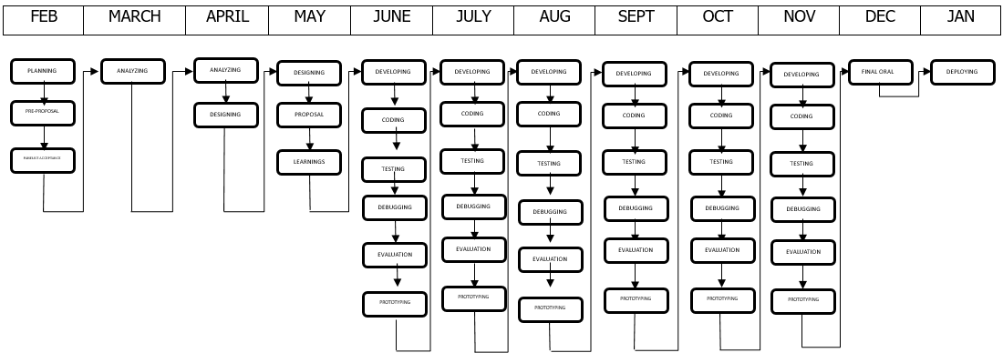

*Fig. 5: Diagram of Agile Process*

**REQUIREMENTS MODELLING (IPO)**

The illustrated input-process-output (IPO) model below serves as a blueprint for the system's core functionalities and anticipated results. Users interact with the system through a user interface, providing necessary information. This information is then processed by the system to achieve a specific outcome, with the user receiving a corresponding message or result upon successful completion.

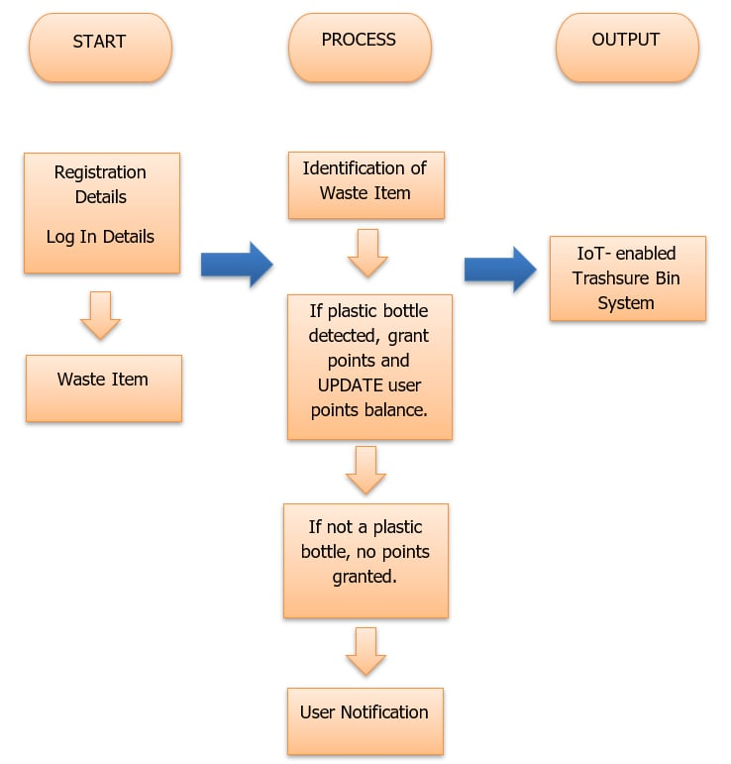

*Fig. 6: Input-Process-Output Diagram*

**OBJECT MODELLING**

The diagram below illustrates the flow of the system from input, process, and output. The input stage includes user registration and login details. Users then initiate the process by depositing recyclables. The system utilizes sensors to automatically identify the type of waste. If a plastic bottle is detected, the program awards points and the users receive feedback or notification through the IOT Trashsure Bin display.

*Fig. 7: Flowchart of the System*

**Data Design**

**Entity Relationship Diagram**

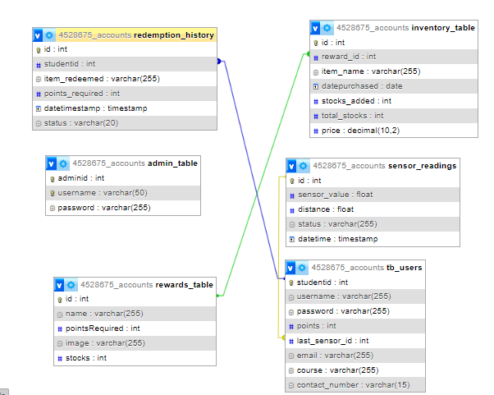The presented entity relationship diagram (ERD) depicts the core components and their interactions within the IOT Trashsure Bin. The central entity is the user represented by students interacting with the system. Users can redeem various rewards offered based on a pre-defined point system. The redeem history entity tracks instances where users exchange points for rewards, capturing the user involved, the specific reward redeemed, and the timestamp of the transaction. This structure suggests a "one-to-many" relationship between users and redeem history, meaning a single user can redeem multiple rewards, while each reward redemption is associated with a unique user.

*Fig. 8: Entity Relationship Diagram*

**SYSTEM ARCHITECTURE**

The diagram below gives a clear picture of how the system works, showing how data moves from the database to the user through the web host. It illustrates the back-and-forth between the user's browser and the database server, highlighting different parts of the system like how it works and what it's made of. These software methods implemented at Cebu Technological University - Argao Campus provide a complete solution for dealing with the challenges of manual data recording.

It provides a detailed look at how the system operates, focusing on how data is fetched from the database and how user requests are managed by the system through the web host. It suggests an innovative solution for improving plastic bottle management by innovating a reward based IoT trading system. By using IoT devices, we can monitor plastic bottle usage in real-time and management becomes more efficient. The reward system encourages students to recycle their plastic bottles by giving them something in return. This could help reduce plastic waste by encouraging more recycling and decrease landfill disposal.

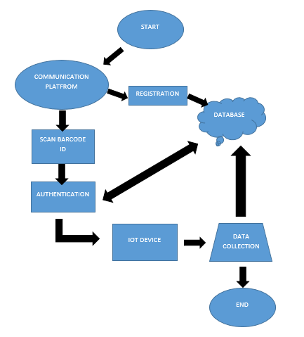

*Fig. 9: The System Architecture*

This Unified Modeling Language (UML) use case diagram depicts the functionalities available to an administrator within the system. The administrator has exclusive access to comprehensive user account management, including creation, editing, and deletion. Additionally, the administrator can review all redeemed points and analyze user point usage patterns through dedicated analytics.

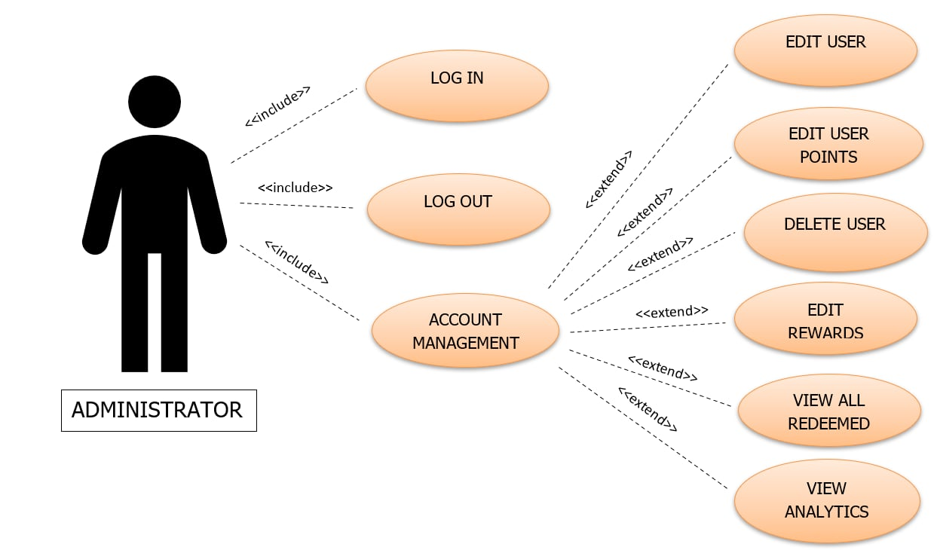

*Fig. 10: Use Case Diagram for Administrator*

This Unified Modeling Language (UML) use case diagram illustrates a user's interaction within the system. The student can leverage the system by logging in, viewing their accumulated points earned through plastic bottle disposal, utilizing those points to redeem rewards, and maintaining a history of their redemptions.

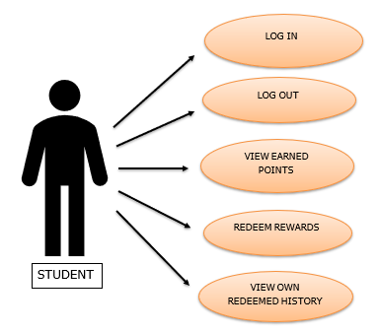

*Fig. 11: Use Case Diagram for Student*

**List of Modules**

**Module 1: Admin**

Functionality 1.1: Log In

Functionality 1.2: Log Out

Functionality 1.3: User Account Management

Functionality 1.3.1: Edit User

Functionality 1.3.2: Edit User Points

Functionality 1.3.3: Delete User

Functionality 1.3.4: Edit Rewards

Functionality 1.3.5: Add Rewards

Functionality 1.3.6: View All Redeemed History

Functionality 1.3.7: View Analytics

Functionality 1.3.8: Inventory

**Module 2: User (Student)**

Functionality 2.1: Log In

Functionality 2.2: Log Out

Functionality 2.3: View Earned Points

Functionality 2.4: Redeem Rewards

Functionality 2.5: View Own Redeemed History

**Testing Plan**

After developing the application, the researchers will test it in several ways to check if it satisfies the objectives and specifications.

**Unit Testing.** This will be the initial test to be performed to check for errors or problems in each module or functionality.

**Integration Testing.** The next action that the researchers will take is this. By connecting them all together, the researchers will attempt to test the system's functionality.

**System Testing.** The researchers will assess the system's overall functionalities during this process.

**Acceptance Testing.** The crucial stage of the testing phase is when the beneficiaries are given the ability to test the created system in accordance with their requirements. Additionally, this will establish whether the system satisfies all requirements for user acceptability and whether users will accept the system or not.

**DEFINITION OF TERMS**

The following terms are presented both theoretically and operationally within the context of their utilization in the study for enhanced comprehension.

**Administrator.** The admin of this study is the supply officer-in-charge of the SSG.

**Agile Software Development Model.** An iterative approach to software development that emphasizes flexibility, collaboration, and customer feedback, enabling teams to respond to changes and deliver functional software incrementally.

**Bar Code Reader.** A device that scans and interprets barcodes of the student ID, converting them into digital data that can be processed and used for crediting the points automatically to ID number.

**Blueprint.** To a detailed plan or design that outlines the essential components, structure, and functionality of a system. It serves as a guide for the development or implementation of the system, providing a clear vision of how it should be constructed and how it will operate.

**Capacitive Sensors.** These sensors play a crucial role in enhancing the efficiency, accuracy, and user experience of the system by providing real-time data on trash levels, facilitating waste sorting, incentivizing recycling, and enabling seamless user interaction.

**Database Server.** To a specialized computer system or software application responsible for managing and storing large volumes of data in a structured manner. It serves as a central repository where data can be accessed, retrieved, and manipulated by multiple users or applications.

**Descriptive Research Design.** A type of research methodology used in the study that focuses on describing the challenges regarding plastic waste management in CTU-Argao Campus.

**Innovating.** To the act of introducing inventive changes or advancements, particularly in the realm of plastic bottle management.

**IoT (Internet of Things).** The network of physical devices, vehicles, home appliances, and other items embedded with electronics, software, sensors, actuators, and connectivity which enables these objects to connect and exchange data.

**Leverage.** To use or exploit something to one's advantage.

**Plastic Bottle Management.** The process of efficiently handling and controlling the usage, disposal, recycling, and overall management of plastic bottles to mitigate environmental hazards associated with plastic pollution.

**PHP.** A recursive acronym for “Hypertext Preprocessor” and the programming language used to be able to dynamically address the functionalities the system should have.

**Redeem.** To exchange or convert something, typically points or credits, for a reward or benefit.

**Reward.** A tangible item or benefit given to users in exchange for participating in waste management. These rewards serve as incentives to encourage individuals to engage in properly disposing of their waste in the IOT Trashsure Bin.

**Trash Bin Trading System.** An innovative system that facilitates the exchange of plastic bottles for rewards or incentives, typically implemented through IoT technology to monitor and manage waste collection and recycling processes.

**Trashsure.** Transforming trash into treasures by earning points and gaining rewards with every plastic bottle thrown in the bin.

**Ultrasonic Sensors.** These sensors measure the distance between the level of trash within a garbage bin. By installing ultrasonic sensors in the bin, the fill level in real-time is continuously monitored.

**Usability.** The degree to which a system or product is easy to use and understand by its intended users, typically measured by factors such as efficiency, learnability, and user satisfaction.

**Usefulness.** The extent to which a system or product fulfills its intended purpose and provides value to its users, often assessed based on its effectiveness in achieving desired outcomes and meeting user needs.

**Waste Management.** The collection, transportation, processing, recycling, and disposal of waste materials. It aims to reduce the adverse effects of waste on human health and the environment.

**Web-Based Monitoring System.** A system that allows users to remotely monitor and manage devices or processes through a web interface, typically providing real-time data, alerts, and controls.

**Weighted Mean.** A type of average calculated by multiplying each data point by its associated weight and then dividing the sum of these weighted values by the total weight. Weighted means are used when some data points are considered more important or representative than others.

**XAMPP server.** Provides a convenient way to set up a local development environment for building and testing the system. It offers a pre-configured bundle of software that streamlines the process of setting up a web server, database server, and scripting environment, allowing the researchers to focus on developing and testing the application.

**SYSTEM GUI**

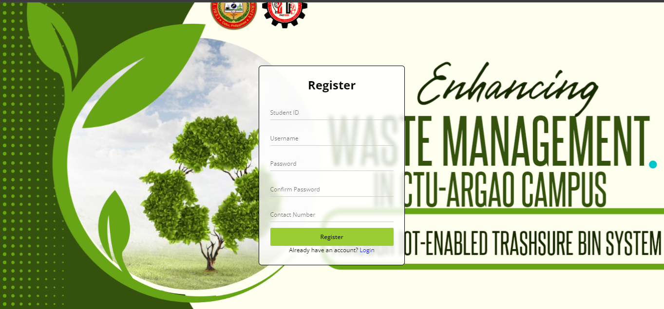

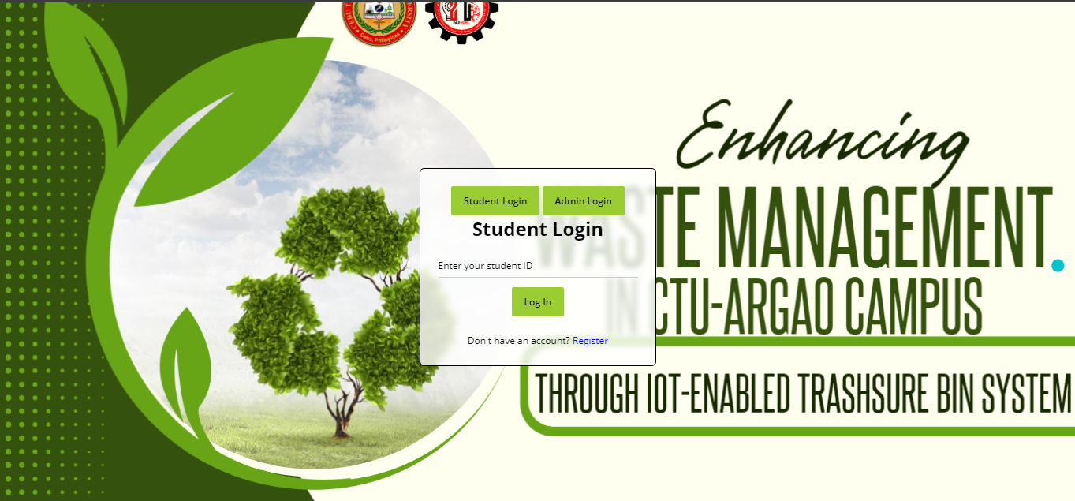

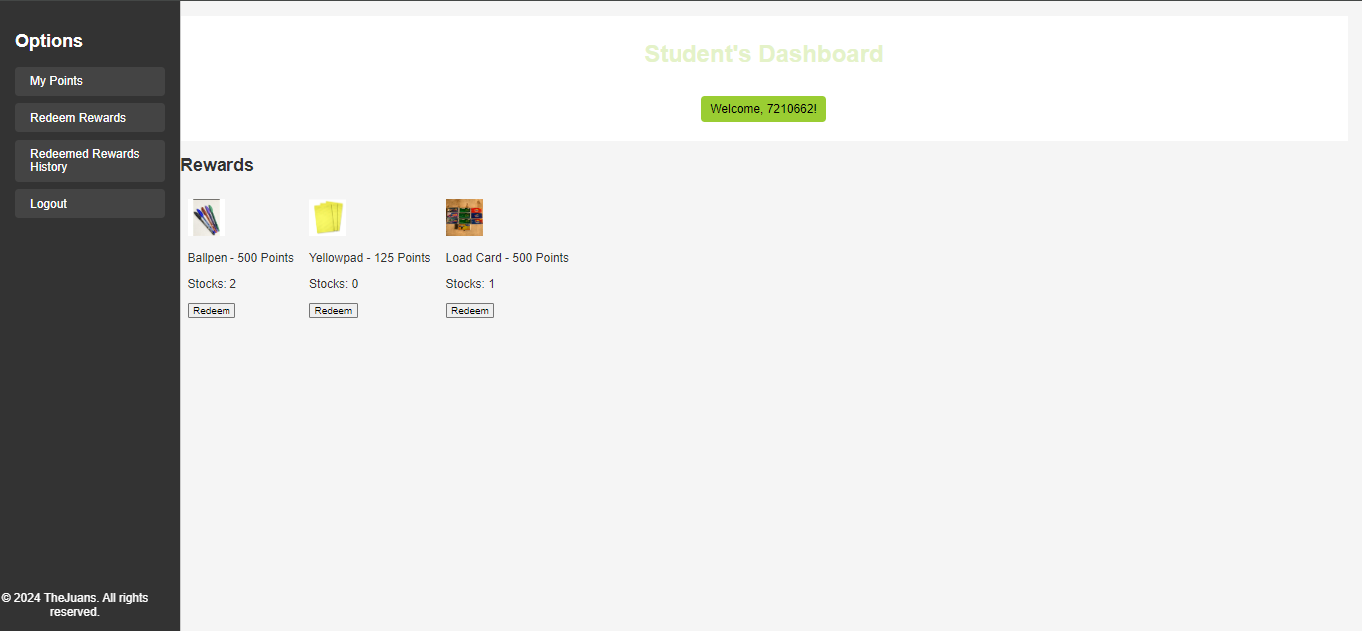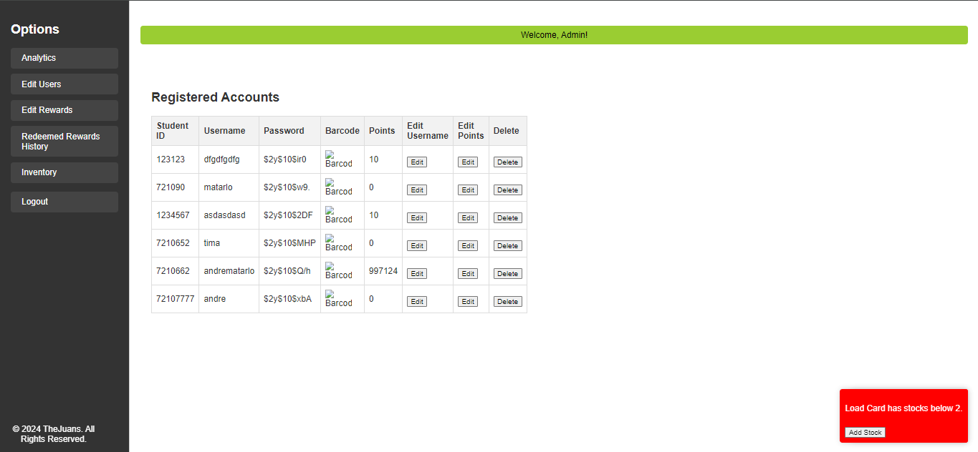

*Fig. 12: System GUI*

**PROJECT 3D DESIGN**

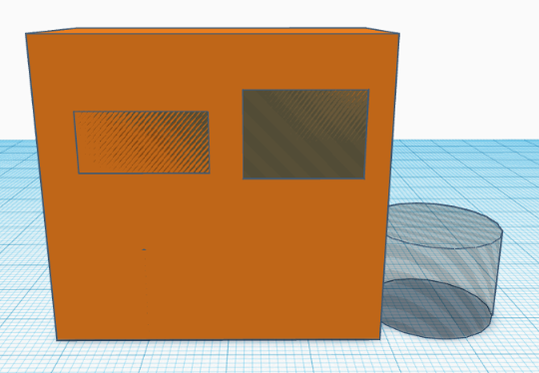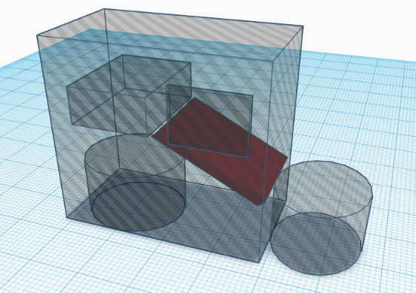

*Fig. 13: Project 3D Design*

**References**

Ranger, S. (2020, February 3). What is the IoT? Everything you need to know about the Internet of Things right now. ZDNet; ZDNet. <https://www.zdnet.com/article/what-is-the-internet-of-things-everything-you-need-to-know-about-the-iot-right-now/>

Reduction of Single-Use Plastic on College Campuses - Oklahoma State University. (2022, August 26). Food.okstate.edu.)

<https://food.okstate.edu/announcements/blog/reduction-of-single-use-plastic.html>

Aikowe, L. D., & Mazancová, J. (2021). Plastic Waste Sorting Intentions among University Students. Sustainability, 13(14), 7526. <https://doi.org/10.3390/su13147526>

Going Hybrid: A Bridge Between Agile and Waterfall | Toptal®. (n.d.-a). Toptal Projects Blog. (2024)

<https://www.toptal.com/project-managers/agile/hybrid-project-management-a-middle-ground-between-agile-and-waterfall#:~:text=What%20is%20a%20hybrid%20Agile>

Worthington, A. K., & Burgess, G. L. (2021). Technology Acceptance Model. Ua.pressbooks.pub. <https://ua.pressbooks.pub/persuasiontheoryinaction/chapter/technology-acceptance-model/>

Kjsce, I., Aman, V., Kjsce, Mumbai, I., Rahul, P., Shweta, D., & Chachra. (2019). Smart Dustbins -Automatic Segregation & Efficient Solid Waste Management using IoT Solutions for Smart Cities Viral Rambhia. International Journal of Engineering Research & Technology (IJERT) Www.ijert.org, 8. <https://www.ijert.org/research/smart-dustbins-automatic-segregation-efficient-solid-waste-management-using-iot-solutions-for-smart-cities-IJERTV8IS120303.pdf>

Bułkowska, K., Zielińska, M., & Bułkowski, M. (2023). Implementation of Blockchain Technology in Waste Management. Energies, 16(23), 7742. <https://doi.org/10.3390/en16237742>

Bhowmik, A., Miah, Md. S. U., & Mohaimen-Bin-Noor. (2020). IoT (Internet of Things) - Based Smart Garbage Management System. AIUB Journal of Science and Engineering (AJSE), 19(1), 33–40.

<https://doi.org/10.53799/ajse.v19i1.55>

Sheng, T. J., Islam, M. S., Misran, N., Baharuddin, M. H., Arshad, H., Islam, Md. R., Chowdhury, M. E. H., Rmili, H., & Islam, M. T. (2020). An Internet of Things Based Smart Waste Management System Using LoRa and Tensorflow Deep Learning Model. IEEE Access, 8, 148793–148811. <https://doi.org/10.1109/access.2020.3016255>

Fadel, F. (2017). The Design and Implementation of Smart Trash Bin. Academic Journal of Nawroz University, 6(3), 141–148. <https://doi.org/10.25007/ajnu.v6n3a103>

Cheema, S. M., Hannan, A., & Pires, I. M. (2022). Smart Waste Management and Classification Systems Using Cutting Edge Approach. Sustainability, 14(16), 10226. MDPI. <https://doi.org/10.3390/su141610226>

Bano, A., Ud Din, I., & Al-Huqail, A. A. (2020). AIoT-Based Smart Bin for Real-Time Monitoring and Management of Solid Waste. Scientific Programming, 2020, e6613263. <https://doi.org/10.1155/2020/6613263>

Chachra, D. (2020). Smart Dustbins - Automatic Segregation Efficient Solid Waste Management using IoT Solutions for Smart Cities. International Journal of Engineering Research And, V8(12). <https://doi.org/10.17577/ijertv8is120303>

Pratap, A., Maria Joshy, A., Mathew, M., John, E., & Treesa James, J. (2019). IoT Based Design for a Smart Plastic Waste Collection System. SSRN Electronic Journal. <https://doi.org/10.2139/ssrn.3356267>

Rajesh, M. V., A. Lakshmanarao, Jai, & Chitturi Devi Priyanka. (2023). IOT based smart system for garbage detection and segregation. <https://doi.org/10.1109/silcon59133.2023.10405323>

Nooriman, W. M., Lim, R., Rudzuan, M. N., Y Sofi, Muhamad Fauzi, & Abdul Halim Abdullah. (2021). Design and Development of IoT based Garbage Monitoring and Management System. Journal of Physics, 2107(1), 012002–012002. <https://doi.org/10.1088/1742-6596/2107/1/012002>

Jayesh Katade, Nachiket Dunbray, Shamla Mantri, Shreyas Mavale, & Sparsh Nimje. (2021). IoT based Incentivized Tech Bins for Smart Cities. <https://doi.org/10.1109/icces51350.2021.9489218>

Bhattacharya, A., Roy, P., & Gupta, R. (2022). The role of IoT-enabled smart bins in urban waste management. Journal of Urban Technology and Management, 15(3), 178-195. doi:10.1080/10788322.2022.2043547

Ellen MacArthur Foundation. (2021). Designing for a circular economy: Innovation and the Internet of Things. Retrieved from https://www.ellenmacarthurfoundation.org/publications/designing-for-a-circular-economy

Katade, S., Patel, D., & Singh, A. (2021). Cleanliness and waste management: The growing challenge of urban waste. Environmental Science and Pollution Research, 28(2), 1345-1356. doi:10.1007/s11356-020-11834-8

Kumar, N., Srivastava, M., & Sharma, R. (2022). Enhancing recycling efforts through IoT: A case study on smart recycling bins. Journal of Environmental Management, 305, 113856. doi:10.1016/j.jenvman.2022.113856

Ma, X., Liu, Y., & Huang, Z. (2021). Policy and technology synergy in mitigating plastic pollution: The role of IoT in waste management. Environmental Policy and Governance, 31(5), 369-384. doi:10.1002/eet.1943

Nooriman, A., Hassan, M., & Abdul, M. (2021). IoT in waste management within the context of the Fourth Industrial Revolution. International Journal of Industrial and Systems Engineering, 45(2), 215-230. doi:10.1504/IJISE.2021.114853

Rajesh, G., Arora, K., & Varma, S. (2023). Automatic garbage segregation: A modern solution to waste management challenges. Waste Management & Research, 41(1), 78-87. doi:10.1177/0734242X231000

Singh, P., & Kumar, V. (2020). Economic benefits of IoT-based waste management systems. Journal of Cleaner Production, 256, 120321. doi:10.1016/j.jclepro.2020.120321

Redhwan Ahmed Al-Naggar, Mahfoudh A.M Abdulghani, & Mahmoud Abdullah Al-Areefi. (2019). EFFECTS OF INAPPROPRIATE WASTE MANAGEMENT ON HEALTH: KNOWLEDGE, ATTITUDE AND PRACTICE AMONG MALAYSIAN POPULATION. Malaysian Journal of Public Health Medicine, 19(1), 101–109.

<https://doi.org/10.37268/mjphm/vol.19/no.1/art.41>